L.N. Gumilev Eurasian National University

Faculty of Information Technologies

"Information systems" department

**REPORT**

**«** **Information Systems Theory and Software Engineering »**

Performed by: Kulakhmetov Yerassyl

Group: IS-23

Verified by: Zhukabaeva T.K.

Astana, 2024

**Introduction**

In the digital age, online shopping has become an integral part of our daily lives, offering convenience and accessibility like never before. With the increasing demand for e-commerce platforms, the development of efficient and user-friendly online stores has become crucial for businesses to stay competitive in the market. The project at hand aims to address this need by creating a robust and intuitive store application that provides users with a seamless shopping experience.

The Store Application project is designed to serve as a comprehensive platform where users can browse and purchase a wide range of products from various categories, including electronics, clothing, books, cosmetics, and more. The application allows users to create an account, log in securely, and explore a diverse selection of products tailored to their preferences.

The pivotal project requirements included:

1. *Jira Project Management:*

To facilitate efficient project management, the utilization of Jira was mandated. This encompassed the creation of an organized and dynamic project plan, detailing tasks, timelines, and dependencies. The Jira board provided a visual representation of the project's progression, fostering collaboration and transparency among team members.

1. *Diagrams:*

Creating diagrams was an essential requirement to visually represent the project's architecture and structure. This involved the construction of class diagrams, use case diagrams, and sequence diagrams, providing a clear blueprint for the development team and stakeholders.

1. *Presentation Development:*

The creation of an engaging and informative presentation was a requisite to effectively communicate the project's objectives, features, and accomplishments. This involved compiling detailed slides on the company's background, interface functionalities.

1. *Report Writing:*

The final requirement encompassed documenting the entire project journey in a comprehensive report. This report was to include an introduction, project overview, development process, challenges faced, solutions implemented, and a reflection on the overall project outcome.

**Jira Plan and GitHub**

Efficient project management played a pivotal role. This section outlines the use of Jira for task tracking, issue resolution, and project organization. Jira is a powerful project management tool developed by Atlassian. Jira became the orchestrator of tasks, the resolver of issues, and the guardian of project organization. The details can be seen in image 1.1.

**Image 1.** Jira Plan

The GitHub repository stands as the digital nucleus of collaboration, version control, and codebase management. GitHub ensures the seamless integration of contributions from various developers, offering a centralized platform for collaboration. From code reviews to issue tracking, the repository embodies transparency, accountability, and the ethos of open-source development. I have uploaded all of the project's content to GitHub.

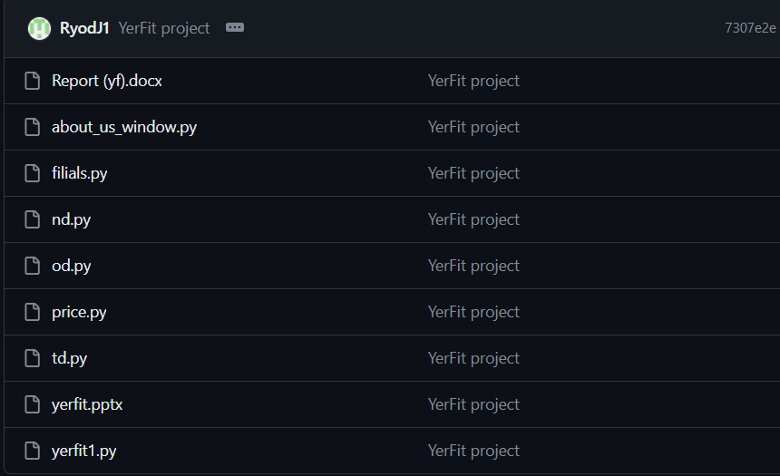

**Image 2.** Files inGitHub

**Graphical Interface Design**

The process of developing a project with JavaFX and Scene Builder involves several key steps, each contributing to the creation of a robust and visually appealing application. In this section, we will outline the process of building a project using JavaFX and Scene Builder, highlighting the key stages and techniques involved.

* Setting Up the Development Environment
* Creating UI Layouts with Scene Builder
* Implementing Functionality with JavaFX
* Integrating Scene Builder Layouts with Java Code

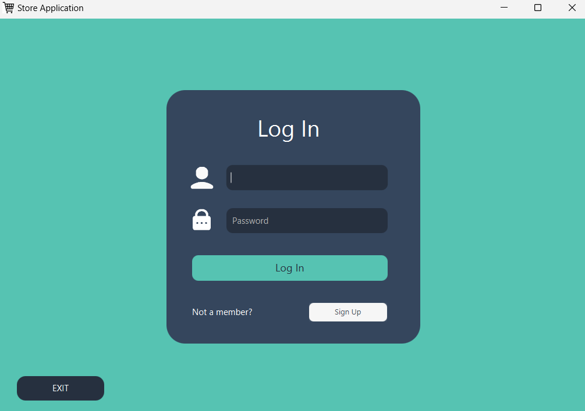

**Image 3.** Login Page

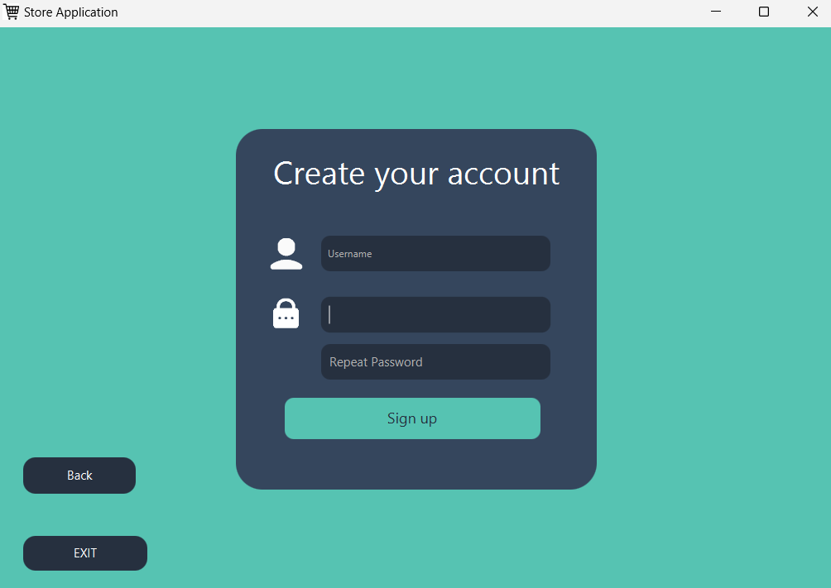

**Image 3.** Sign Up Page

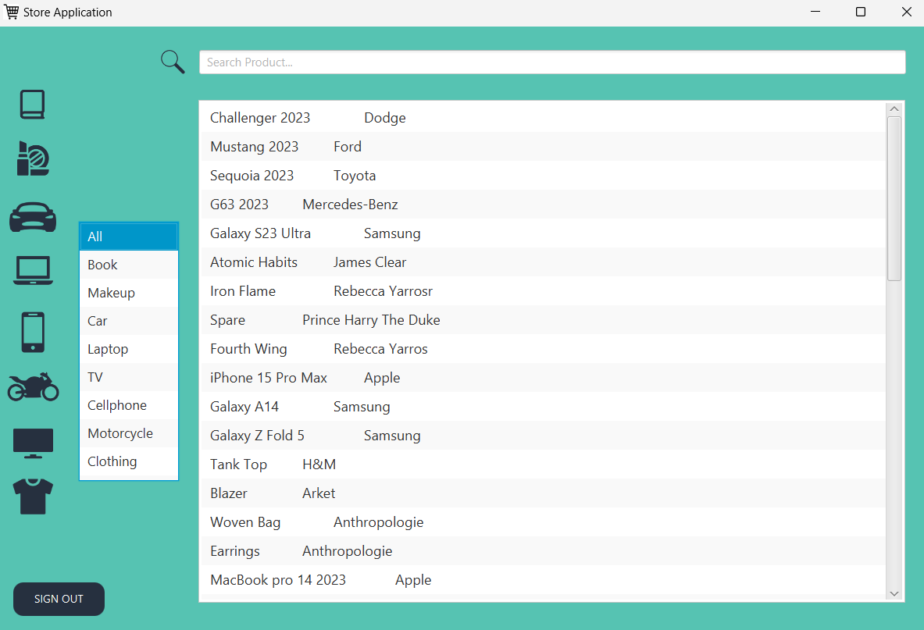

**Image 4.** Main Page

**Database Integration**

Use of MongoDB:

Integrating a database into a JavaFX project is essential for storing and managing data efficiently. MongoDB, a popular NoSQL database, offers a flexible and scalable solution for storing semi-structured data, making it an ideal choice for JavaFX applications.

To interact with MongoDB from our JavaFX application, we need to include the MongoDB Java driver as a dependency in our project. Once the MongoDB Java driver is included in our project, we can establish a connection to the MongoDB database from our JavaFX application. This involves creating a MongoClient object and specifying the connection details such as the hostname, port, and database name.

**UML Diagram and Flowchart**

In the process of creating our JavaFX project, we employed Unified Modeling Language (UML) diagrams and flowcharts to visualize the structure, behavior, and flow of our application. These diagrams provide a clear representation of the project's architecture, design, and functionality, facilitating communication among team members and stakeholders. The UML is provided in image 6.

**Image 6.** UML Diagram



**Image 7.** Flowchart Diagram